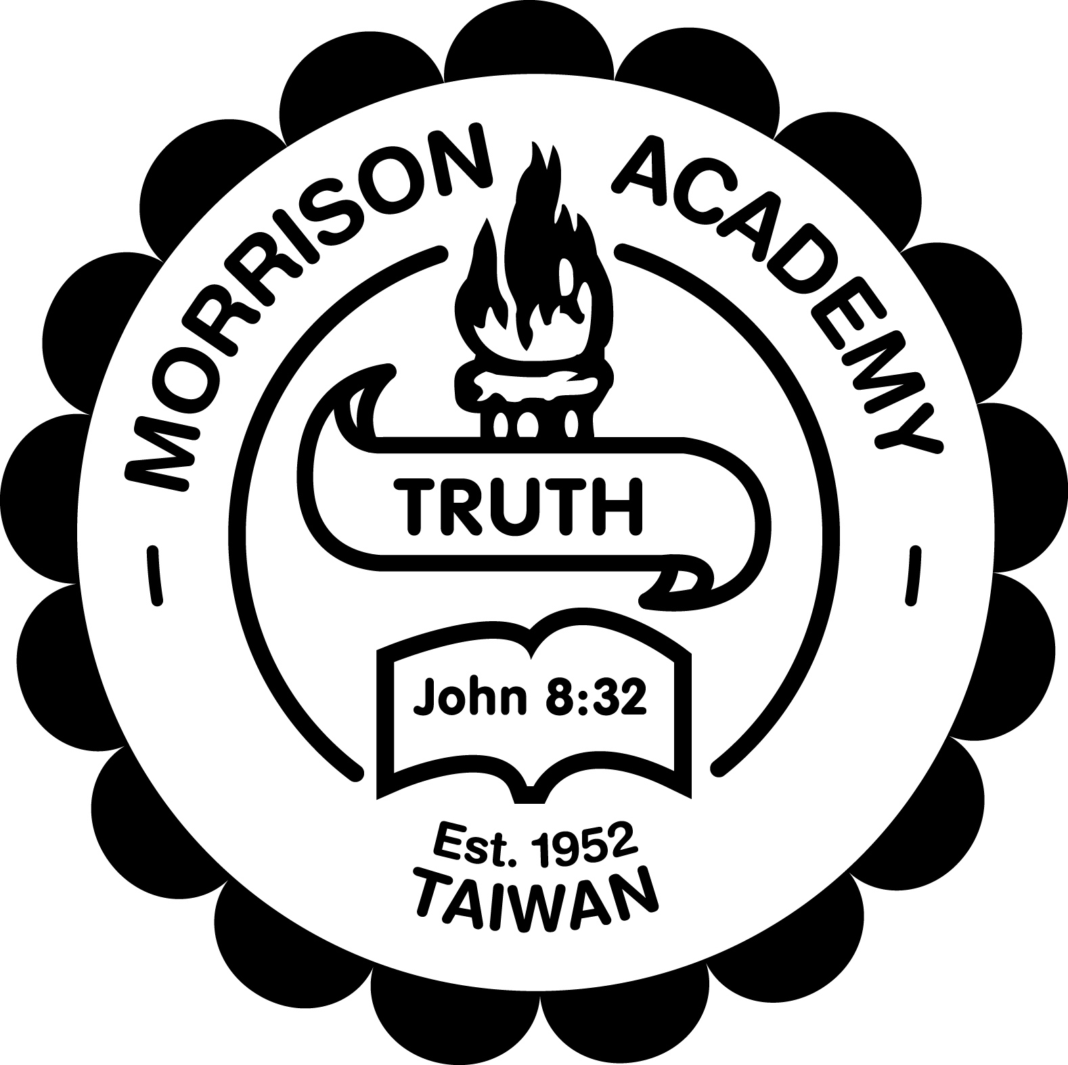
MORRISON ACADEMY
LIBRARIAN APPLICATION FORM

Please fill out this form electronically. All information will be held in confidence.

Name: |  | Date:
Present Address: |  | Tel:  Email:  Soc. Sec.
Personal/Emergency Contact: (Someone who will not be coming to Taiwan who would always know how to contact you) | Name and address: | Tel:  Email:
Home of Record: (address where you will return during any summers at home) |  | Available as of:  Length of Anticipated stay at Morrison:

MARITAL STATUS: Single Engaged Married Widowed Ever Divorced*
*If ever divorced, please include an explanatory statement.

YOUR BIRTHDATE: (And those of family members who live at home)
 | Name | Birthdate | Marriage Date
APPLICANT
Spouse
Child
Child
Child
Child

Spouse desires employment at Morrison Academy, but this would not be essential
Spouse would require employment at Morrison Academy.

WORK EXPERIENCE: (Please include volunteer work if it involved children)
Employer/Company | Position Held | Years (From - To) | Reason for Leaving

EDUCATIONAL HISTORY: (After High School)
Schools Attended (Include State and Country | Years (From - To) | Major and Degree Earned

INDICATE RELATIVES OR FRIENDS CURRENTLY OR FORMERLY EMPLOYED AT MORRISON.

RECENT CO-CURRICULAR AND COMMUNITY ACTIVITIES:

DISCUSS A POSITIVE EXPERIENCE WORKING IN A TEAM AND DESCRIBE YOUR ROLE IN MAKING THE TEAMWORK WELL.

DESCRIBE YOUR EXPERIENCE AND LEVEL OF EXPERTISE USING INFORMATION TECHNOLOGY.

WHAT FOREIGN LANGUAGES DO YOU SPEAK OR READ?

HAVE YOU TRAVELED OR STUDIED ABROAD? PLEASE DESCRIBE.

DESCRIBE THE LORD'S LEADING IN YOUR LIFE TOWARD SERVING IN A SCHOOL FOR MISSIONARY CHILDREN. IF MARRIED, PLEASE INDICATE FAMILY’S SUPPORTIVENESS OF THIS LEADING.

DESCRIBE HOW AND WHEN YOU BECAME A CHRISTIAN. FURTHERMORE, DESCRIBE YOUR SPIRITUAL GROWTH AND RELATIONSHIP TO A LOCAL CHURCH DURING THE PAST FIVE YEARS.

WHAT IS YOUR ATTITUDE TOWARD NON-CHRISTIAN RELIGIONS?

DO YOU FEEL YOU CAN WORK COOPERATIVELY IN A MULTI-MISSION SITUATION WITH PEOPLE FROM MANY DIFFERING DENOMINATIONS AND THEOLOGICAL BACKGROUNDS? PLEASE EXPLAIN.

WHAT IS YOUR DENOMINATIONAL PREFERENCE?

WHAT DOES A GREAT K-12 LIBRARY LOOK LIKE TO YOU? DESCRIBE A PICTURE OF A BUSY TIME IN THE LIBRARY. WHAT ARE STUDENTS DOING?

SCHOOL LIBRARIANS AT MORRISON HAVE TO BE ABLE TO RELATE TO PEOPLE ACROSS WIDE AGE RANGES, DIVERSE CULTURAL BACKGROUNDS AND EVEN A VARIETY OF CHRISTIAN PERSPECTIVES. PLEASE DESCRIBE HOW YOU WOULD PROMOTE THE LIBRARY PROGRAM TO OUR COMMUNITY.

WHAT IS YOUR LIBRARY MANAGEMENT PLAN? HOW WOULD YOU COMMUNICATE EXPECTATIONS TO STUDENTS, PARENTS, AND COMMUNITY MEMBERS?

HOW WOULD YOU HANDLE STUDENT BEHAVIOR PROBLEMS IN THE LIBRARY?

IN YOUR OPINION WHAT SHOULD A COLLECTION IN A CHRISTIAN SCHOOL WITH AN AMERICAN CURRICULUM LOOK LIKE?

TELL US ABOUT A COLLABORATIVE LESSON YOU HAVE USED THAT INCORPORATED INFORMATION LITERACY SKILLS. WHAT GRADE/SUBJECT? WHAT STAGES OF THE LESSON WERE YOU INVOLVED IN? (PLANNING, RESOURCE PROCUREMENT, IMPLEMENTATION, ASSESSMENT, REVISION)

WHAT DO YOU LIKE TO READ FOR PLEASURE? HOW WOULD YOU ENSURE YOUR LIBRARY IS PROMOTING A VARIETY OF BOOKS AND NOT JUST YOUR PERSONAL FAVORITES?

TELL US ABOUT ANY DIRECT SUPERVISORY EXPERIENCE YOU HAVE HAD IN THE PAST. LIST 3 LIBRARY RELATED TASKS/JOBS YOU WOULD DELEGATE TO A PAID LIBRARY ASSISTANT, STUDENT AID OR PARENT VOLUNTEER. EXPLAIN YOUR RATIONALE FOR SELECTING THESE THINGS.

MORRISON LIBRARIES PROMOTE OPEN ACCESS TO COLLECTIONS AND FACILITIES. WHAT WOULD THAT LOOK LIKE IF YOU WERE IN CHARGE OF A MORRISON LIBRARY?

DESCRIBE A UNIQUE LESSON YOU HAVE TAUGHT FOR PRIMARY STUDENTS INCORPORATING A LITERATURE THEME, GENRE OR CURRICULUM GOAL. WHAT WAS THE INSTRUCTIONAL GOAL? HOW DID YOU ASSESS WHETHER OR NOT STUDENTS LEARNED?

TELL US ABOUT A SPECIAL EVENT YOU HAVE USED IN THE PAST OR WOULD USE AS A MORRISON LIBRARIAN TO PROMOTE LITERATURE/READING OR LIBRARY USAGE. WHAT SPECIFIC BENEFITS WOULD STUDENTS GET FROM THE EVENT?

I HAVE READ AND AGREE TO ABIDE BY THE SCHOOL’S POLICIES AS OUTLINED ONLINE AT http://www.mca.org.tw/policies-to-read AND I AM PREPARED TO COOPERATE WITH COLLEAGUES AND THE ADMINISTRATION UNDER THE AUTHORITY OF THE MORRISON BOARD OF TRUSTEES. Yes No

MORRISON CHRISTIAN ASSOCIATION STATEMENT OF FAITH

- The divine inspiration and consequent authority of the whole canonical Scriptures.
- The doctrine of the Trinity.
- The doctrine of the deity of our Lord Jesus Christ, His virgin birth, His sinless life, His miracles, His vicarious and atoning death through His shed blood, His bodily resurrection, His ascension to the right hand of the Father, and His personal return in power and glory.
- The fall of man, his consequent moral depravity and his need of regeneration.
- The atonement through the substitutionary death of Christ.
- The doctrine of justification by faith.
- The present ministry of the Holy Spirit, by whose indwelling the Christian is enabled to live a holy life.
- The resurrection of the body, both in the case of the just and the unjust.
- The eternal life of the saved and the eternal punishment of the lost.

I CERTIFY THE ABOVE STATEMENT OF FAITH TO BE AN ACCURATE AND CORRECT STATEMENT OF MY PERSONAL BELIEFS.
Yes No

HAVE YOU EVER BEEN ARRESTED AND/OR CONVICTED FOR A FELONY? YES NO
(If yes, please explain)

HAVE YOU EVER BEEN ACCUSED, ARRESTED, AND/OR CONVICTED FOR CHILD MOLESTATION OR ABUSE? YES NO
(If yes, please explain)

BY SIGNING BELOW, I UNDERSTAND THAT I AM PROVIDING THE FOLLOWING VERIFICATION AND AUTHORIZATIONS:

Verification as to Accuracy of Information
I certify that the information provided on this application is accurate. I understand that any misstatement of material facts will be grounds for disqualification from further consideration in the selection process, or, if hired, will be grounds for discharge.

Authority to Conduct Reference and License Check
I understand that consideration for employment with Morrison Christian Academy (a part of Morrison Christian Association) is contingent upon the results of a reference check. I authorize Morrison to investigate any statements made on the application and to contact former employers and references including secondary references. I also authorize contacted persons to respond fully to any questions. I also consent to release all education and professional license information from any educational institution or professional licensing agency listed by me and release such educational institutions and professional licensing agencies and Morrison Christian Academy from any liability under the Family Education Rights and Privacy Act or any other state or federal law or regulation.

Authority to Obtain Criminal History Background Check
I authorize Morrison Christian Academy to obtain criminal history information or to do a national criminal history background check as a condition of employment. I release Morrison Christian Academy and any third party providing such information from any and all liability with regard to the provision of such information or Morrison Christian Academy’s use of the same.

I AGREE TO THE ABOVE STATEMENT. Yes No

Date Signature (If this form is returned by email type your name).

SAVE AS A DOCUMENT THEN RETURN VIA E- MAIL OR FAX: (Please do not send as a Google Doc.)

Recruitment Office E-Mail: recruitment@mca.org.tw
216 Si Ping Road, Taichung, Tel: 886-4-2297-3927
Taiwan 406-79

